Project Concept
[Project Name]
Date submitted: [Date]

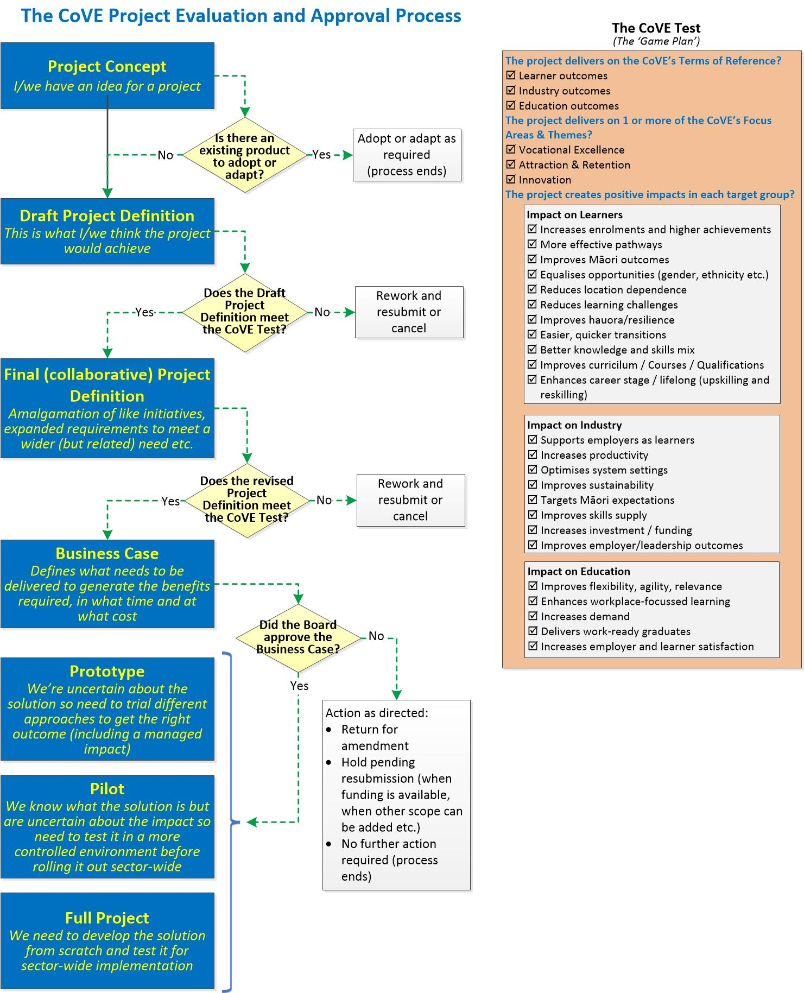

Email the completed form (or if you have any questions) to the Portfolio Management Office at:
projects@foodandfibrecove.nz

Originator
Organisation:

Lead Contact:
Name: | Appointment: Chair
Phone: | Email:

Opportunity or Issue
Briefly describe the opportunity or issue.

Driver
Briefly outline the circumstances which make this a genuine need. That is, what was it that prompted you to initiate the proposal?

Strategic Alignment
Which of the following outcome areas would be improved because of this project? (Select all that apply)
☐ Learner outcomes ☐ Industry outcomes ☐ Education outcomes
Which focus areas best apply?
☐ Vocational Excellence ☐ Attraction and Retention ☐ Innovation
Which of the following target groups are impacted? (Select all that apply)
Learners:  ☐ Increases enrolments and higher achievements  ☐ More effective pathways  ☐ Improves Māori outcomes  ☐ Equalises opportunities (gender, ethnicity, disabilities etc.)  ☐ Reduces location dependence  ☐ Reduces learning challenges  ☐ Improves hauora/resilience  ☐ Easier, quicker transitions  ☐ Better knowledge and skills mix  ☐ Improves curriculum/courses/qualifications  ☐ Enhances career stage/lifelong (upskilling and reskilling) | Industry:  ☐ Supports employers as learners  ☐ Increases productivity  ☐ Optimises system settings  ☐ Improves sustainability  ☐ Targets Māori expectations  ☐ Improves skills supply  ☐ Increases investment/funding  ☐ Improves employer/leadership outcomes | Education:  ☐ Improves flexibility, agility, relevance  ☐ Enhances workplace-focussed learning  ☐ Increases demand  ☐ Delivers work-ready graduates  ☐ Increases employer and learner satisfaction

Expected Benefits
What would the benefits be of doing this?

Time and Cost Estimates
How long to deliver? | ☐ Less than a month ☐ Less than 6 months  ☐ Less than 3 months ☐ More than 6 months
Best guess at cost | ☐ Nothing (collaboration only) ☐ Less than $20,000  ☐ Less than $50,000 ☐ Less than $100,000  ☐ More than $100,000

Potential Collaborators
Which other organisations might be interested in this initiative? Indicate if they already know about it.

Other Information
Any other information which might be relevant?

