Project Definition / Small Project Business Case (delete one)
[Name of proposed project]
Date submitted: [Date]
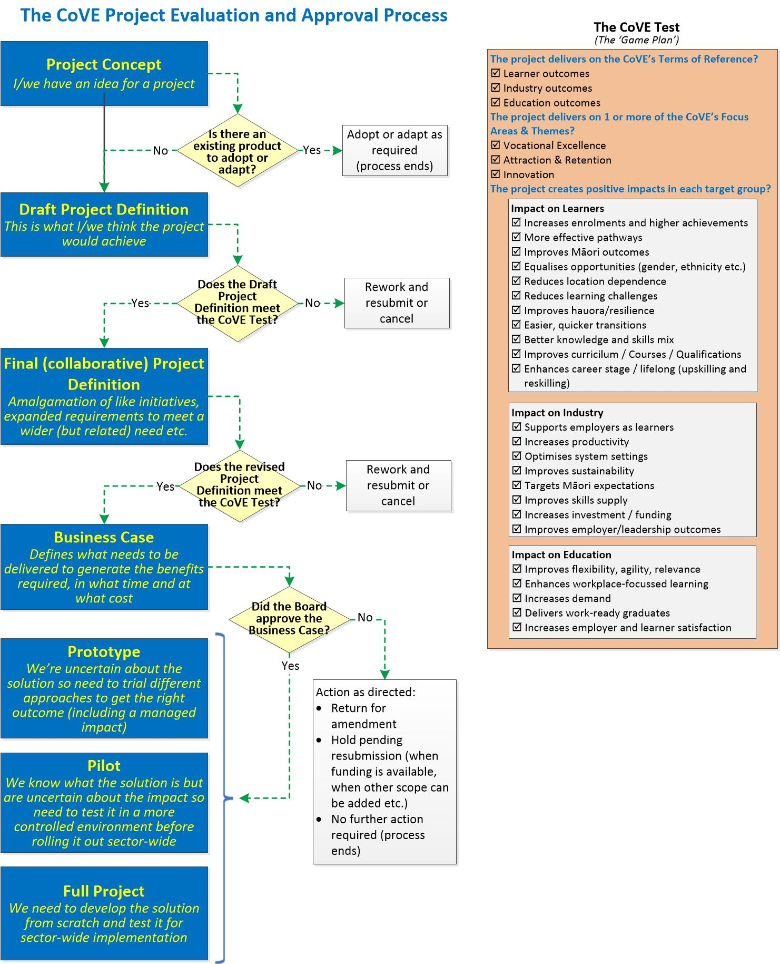
Email the completed form to the assigned FFCoVE Portfolio Manager. If you don’t know who this is, send it to:
projects@foodandfibrecove.nz

Originator
Organisation:

Lead Contact:
Name: | Appointment:
Phone: | Email:

Commitment to Māori and the diversity of other population groups
The Food and Fibre CoVE (‘the CoVE’) is committed to honouring and giving effect to the Treaty of Waitangi in all of its activities. Critically, this involves supporting the advancement of Māori-led and mātauranga informed workforce development solutions in the food and fibre sector while recognising the importance of Te Ao Māori, especially te reo and tikanga in the everyday life of the CoVE. This commitment is particularly important in the implementation of changes across the Food and Fibre sector through its programme of work.
The CoVE also recognises the increased diversity of people wanting to study and work in the Food and Fibre sectors at all levels and will take every opportunity to integrate these needs too into each and every change activity.

Background
If the project is fixing an issue, provide a short history and include a problem statement (a description of the problem itself and why it is important it be resolved; what needs to change and what we should measure to prove the problem has been solved.)
If this is an opportunity, provide a brief description of the current state, describe how this project would change that and what we would see when has successfully been delivered.)

Alignment with Other Projects
If known, identify all other projects (actual or planned) where there may be opportunities for synergy. Note that the expectation in the first instance is for the CoVE to be responsible for managing any such synergies.

Proposal
Describe the proposed project as it now is after the consultation process and landscape scan etc.

Scope and beneficiaries
Provide the reference to the Project Concept document and briefly describe the outcome of the consultation process for it.
This section also summarises the outcomes from a landscape scan. For example, has this initiative been merged with another proposal or has the scope been extended to deliver a related product or service etc? Have CoVE’s knowledge bases been reviewed for potential solutions?

      - Describe the initiative as agreed through the consultation process by clearly defining the scope as it now stands.
      - What other organisations might benefit from this project if it were to proceed?
Is it likely that other organisations (whether in the Food and Fibre sector or another sector) would be experiencing the same issue(s) or could leverage the same opportunity? Include contact information if known. If you have discussed this opportunity or issue with other organisations list them also along with a summary of the outcome of the discussion (full agreement, part agreement, they have the same issue but get a different outcome etc.)

Strategic Alignment
- Which of the following outcome areas would be improved as a result of this project?
(Select all that apply)
☐ Learner outcomes ☐ Industry outcomes ☐ Education outcomes
- Which of the following focus areas best applies?
☐ Vocational Excellence ☐ Attraction and Retention ☐ Innovation
- Which of the following target groups are impacted? (Select all that apply)
Learners:  ☐ Increases enrolments and higher achievements  ☐ More effective pathways  ☐ Improves Māori outcomes  ☐ Equalises opportunities (gender, ethnicity, disabilities etc.)  ☐ Reduces location dependence  ☐ Reduces learning challenges  ☐ Improves hauora/resilience  ☐ Easier, quicker transitions  ☐ Better knowledge and skills mix  ☐ Improves curriculum/courses/qualifications  ☐ Enhances career stage/lifelong (upskilling and reskilling) | Industry:  ☐ Supports employers as learners  ☐ Increases productivity  ☐ Optimises system settings  ☐ Improves sustainability  ☐ Targets Māori expectations  ☐ Improves skills supply  ☐ Increases investment/funding  ☐ Improves employer/leadership outcomes | Education:  ☐ Improves flexibility, agility, relevance  ☐ Enhances workplace-focussed learning  ☐ Increases demand  ☐ Delivers work-ready graduates  ☐ Increases employer and learner satisfaction

Expected Benefits
- What tangible benefits would be likely if the opportunity were met or the issue resolved? (Cost savings, better student outcomes, better course delivery etc.)
- What intangible benefits would be likely if the opportunity were met or the issue resolved? (Improved student or staff satisfaction, intellectual property, goodwill etc.)

Time and Cost Estimates
- How long do you think it would take to investigate, design and develop a solution, test it and then make it available to users?
☐ Less than a month ☐ Less than 3 months
☐ Less than 6 months ☐ More than 6 months
- What do you think it might cost (labour, materials etc.) It’s just a guess to give the CoVE some idea of how complex a project this might be.
☐ Nothing (collaboration only) ☐ Less than $20,000
☐ Less than $50,000 ☐ Less than $100,000
☐ More than $100,000
- What do you think the ongoing annual operating costs would be?
☐ Nothing ☐ Less than $600
☐ Less than $1,200 ☐ Less than $2,400
☐ More than $2,400 (if so, what is the estimated annual operating cost: __________ )

Potential Collaborators
- List other organisations which might be interested in collaborating on this initiative. Indicate if you’ve confirmed they’re interested or that you’re proposing they be approached to join. Add more lines if required.
Partner Organisation(s)
☐ Confirmed ☐ Proposed
☐ Confirmed ☐ Proposed
☐ Confirmed ☐ Proposed
☐ Confirmed ☐ Proposed

Other Comments

Add any other comments necessary to clarify options, explain the risk profile, identify assumptions, constraints etc.

Appendix A: Proposed Solution
Describe the key characteristics of the solution needed to address the opportunity or issue. That is, what would a high=level project plan look like (who does what and by when) and how success would be measured.
Typically this would be a bullet list of what the project would do (and would not do because a related deliverable is being produced by another project or already exists) and what difference would be seen by the eventual users of the project’s outputs.

