Business Case
[Name of proposed project]
Date submitted: [Date]

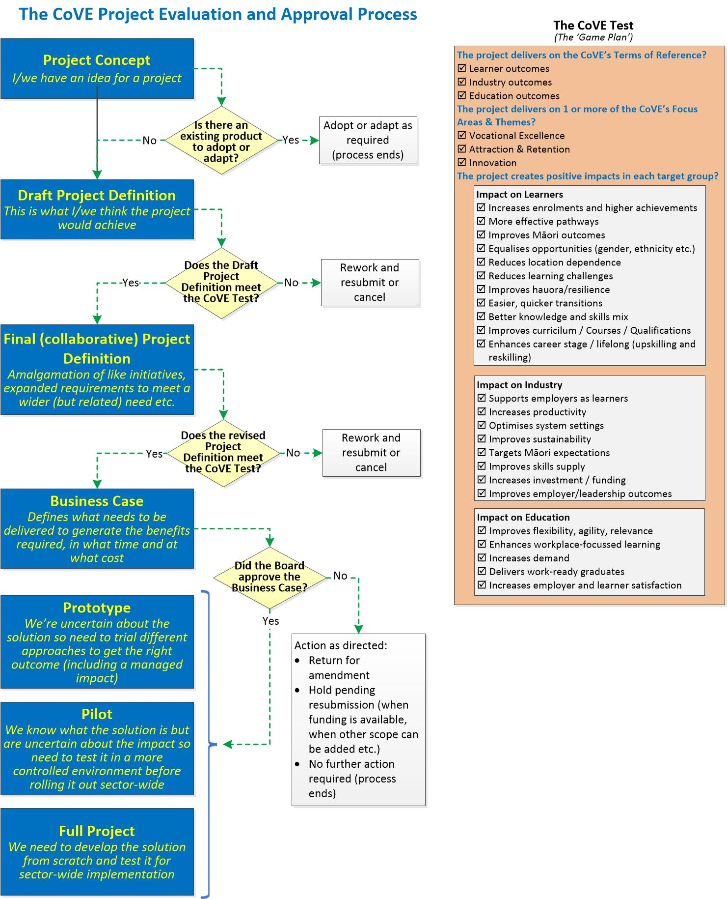
Email the completed form (or, address any questions) to the assigned Portfolio Manager. If, for some reason, you don’t know who this is, email it to projects@foodandfibrecove.nz

Originator
Organisation:

Lead Contact:
Name: | Appointment:
Phone: | Email:

Commitment to Māori and the diversity of other population groups
This section can be removed if the template is being used for a Project Definition (but should be retained if used for a Small Project Business Case)
The Food and Fibre CoVE (‘the CoVE’) is committed to honouring and giving effect to the Treaty of Waitangi in all of its activities. Critically, this involves supporting the advancement of Māori-led and mātauranga informed workforce development solutions in the food and fibre sector while recognising the importance of Te Ao Māori, especially te reo and tikanga in the everyday life of the CoVE. This commitment is particularly important in the implementation of changes across the Food and Fibre sector through its programme of work.
The CoVE also recognises the increased diversity of people wanting to study and work in the Food and Fibre sectors at all levels and will take every opportunity to integrate these needs too into each and every change activity.

Vision
What is your vision for the project? That is, when implemented:
- What strategic objective(s) will be achieved?
- What significant differences will the user community experience as a result of this project?

Background
If the project is fixing an issue, provide a short history and include a problem statement (a description of the problem itself and why it is important it be resolved; what needs to change and what we should measure to prove the problem has been solved.)
If this is an opportunity, provide a brief description of the current state, describe how this project would change that and what we would see when has successfully been delivered.)
Provide the reference to the Project Concept document and briefly describe the outcome of the consultation process for it. For example, has this initiative been merged with another proposal or has the scope been extended to deliver a related product or service etc? What has the FFCoVE said about the initiative?

Business Case Sponsor
Who is the proposed sponsor for the project if it is approved?

Issue or Problem Definition or Opportunity (delete as appropriate)
An explicit, tightly defined description of the issue or problem or opportunity which answers the following questions:
- What is/are the key issue(s) to be addressed and why is it important?
- Who is it an issue, problem or opportunity for?
- What factors shape this issue, problem or opportunity? Consider those of the following which apply; political, economic, social, technology, environmental and/or legal (including regulation or policy).
- What evidence is available which supports the issue or problem or opportunity as defined above?

Primary and Enabling Objectives
A detailed list of unambiguous statements which encapsulate what this project is all about (the 30 second ‘elevator message’). A primary objective is a high-level outcome (usually one, two or three items) expressed as a success measure.
Expand on each primary objective (if necessary) by listing the (ideally no more than five or six) enabling objectives which, once they are achieved, will ensure the primary objective will be achieved. If it helps, think of these in terms of the outcomes which learners, learning providers, and industry and employers would see when the project ends.
[Primary Objective 1]
- [Enabling Objective 1
- Enabling Objective 2
- . . .]
[Primary Objective 2
- Enabling Objective 1
- Enabling Objective 2
- . . .]

Scope
What are logical deliverables which, when they have all been achieved, mean that the project will have met its objectives? If there is the possibility of confusion, include what isn’t in scope in the Comments field. The Start week column reflects the number of weeks from when the Business Case is approved. Deliverables can overlap. Add more lines if required.
Deliverables | Start (week #) | End (week #) | Comments
 | 1
If the project is multi-staged, create a separate table for each stage (show the stage name in the top row above the ‘Deliverables’ heading.

Alignment with Other Projects
If known, identify all other projects (actual or planned) where there may be opportunities for synergy. Note that the expectation in the first instance is for the FFCoVE to be responsible for managing any such synergies.

Options Analysis
Summarise what options were considered on the way to identifying the preferred. This should include a discussion on what the outcomes would be if the project did not proceed (the ‘do nothing’ or ‘status quo’ option). Assess each option in terms of:
- Benefits and disadvantages
- Costs
- Risks
- Impact on stakeholder groups
- Other significant factors which are specific to this type of project
Option 1: Do Nothing

Option 2: [Option title]

Option 3: [Option title]

Comparison of Options
CRITERIA | OPTION 1 | OPTION 2 | OPTION 3
BENEFITS
DISADVANTAGES
COSTS
RISKS
Other

Recommended Option
Clearly identify the recommended option and the rationale used which led to that preferred solution over the others.

Benefits Assessment
(For Anticipated benefits below, see the FFCoVE Game Plan for categories within each focus area.).
Benefit Name:
Outcome area | ☐ Learner outcomes ☐ Industry outcomes ☐ Education outcomes
Focus area | ☐ Vocational excellence ☐ Attraction/Retention ☐ Innovation
Type of benefit | ☐ Financial ☐ Efficiency ☐ Effectiveness
Financial | ☐ Cost-reducing ☐ Revenue-generating ☐ Non-financial
Measurability | ☐ Quantitative ☐ Qualitative
Anticipated benefit | Describe the benefit and how it would be measured

Benefit Name:
Outcome area | ☐ Learner outcomes ☐ Industry outcomes ☐ Education outcomes
Focus area | ☐ Vocational excellence ☐ Attraction/Retention ☐ Innovation
Type | ☐ Financial ☐ Efficiency ☐ Effectiveness
Financial | ☐ Revenue-generating ☐ Cost-reducing ☐ Non-financial
Measurability | ☐ Quantitative ☐ Qualitative
Anticipated benefit | Describe the benefit and how it would be measured

Project Budget
- Summarise the budget here for the recommended option. Provide the detail in Appendix A or as a separate attachment (Request the template from the FFCoVE PMO)
Funding: Funding Provider | Amount (S) | Comments
Food and Fibre CoVE | nn,nnn
Other contributor | nn,nnn
Other contributor | nn,nnn
Total Project Funding
In-kind contributions | Value ($) | Type of contribution
Other contributor | nn,nnn | Describe and quantify the product, service or resource etc.
Other contributor | nn,nnn
Total In-kind Value
Cost Breakdown | Cost ($) | Comments
Deliverable 1
Deliverable 2
Deliverable 3
Total Project Cost
Project Contingency
Annual Operating Costs | ($ per annum) | Comments
Activity | nn,nnn | Include any qualifiers e.g. payment by other than the CoVE
Activity | nn,nnn
Total annual cost

Project Partners
- List other organisations collaborating on this initiative. Add more lines if needed
Partner Organisation(s)
Organisation:  Contact name: | Contact number:  Contact email:
Organisation:  Contact name: | Contact number:  Contact email:
Organisation:  Contact name: | Contact number:  Contact email:
Organisation:  Contact name: | Contact number:  Contact email:

Delivery Approach
Outline how you think the project would be delivered.
Activity | Key  Deliverable(s) | By whom, by when | Comments
- List the main tasks required to deliver the first deliverable with each task beginning on a new line  - . . . | Deliverable 1 | Main participants for deliverable 1  MMMYY | Only include comments where they’re needed to avoid potential confusion or refer to a dependency etc. A straight-forward project would have no comments.
- List the main tasks required to delivery the second deliverable with each task beginning on a new line  - . . .  - . . . | Deliverable 2 | Main participants for deliverable 2  MMMYY
- . . . | . . . | . . .
- . . .  - . . . | ‘ ‘ ‘ | . . .
- Release for adoption | Final product or service | . . .

Assumptions and Constraints
An assumption is something accepted as true in order to progress the business case but still to be proved. That is, there may be a risk that the assumption is wrong and, if it is, the project may be impacted.
A constraint is a limitation which the project must take into account. Examples include access to scarce resources, a non-negotiable target date, a funding limit etc.

Risks
- A risk is something which, if it occurred, would negatively impact the project. Provide a list of the key risks the project would need to manage (Likelihood and Impact both 3 or higher).
Rate on a scale of 3 to 5 where:
- For Likelihood: 1 = Rare, 2=Unlikely, 3=Possible, 4=Likely, 5=Almost certain
- For Impact: 1=Insignificant, 2=Minor, 3=Moderate, 4=Major, 5=Critical
Risk | Likelihood | Impact | Treatment | Contingency*
 |  |  | Total contingency | $
* Contingency is an amount of funds, additional to the approved project cost, to cover estimated risk exposure. This amount is also recorded in Section 8 (against Project Contingency).

Appendix A: Summarised Budget
Either paste a screen print of your summarised budget here or provide an Excel spreadsheet as a separate attachment. The FFCoVE can provide a budget template (Excel spreadsheet) on request.

Contingency is a reserve fund – held separate from project funds – to address project risk (and is the total additional cost if all of the financial related impacts of the risks at Section 15 came to pass). Draw down of contingency will be a separate management decision as delegated by the project sponsor.

